Create a simple cloud software application for Library book reservation system for SIMATS library using any Cloud Service Provider to demonstrate SaaS include the necessary fields such as Title of the book, author, publications, Year, edition, no of copies, Rack no, status (taken/returned) etc

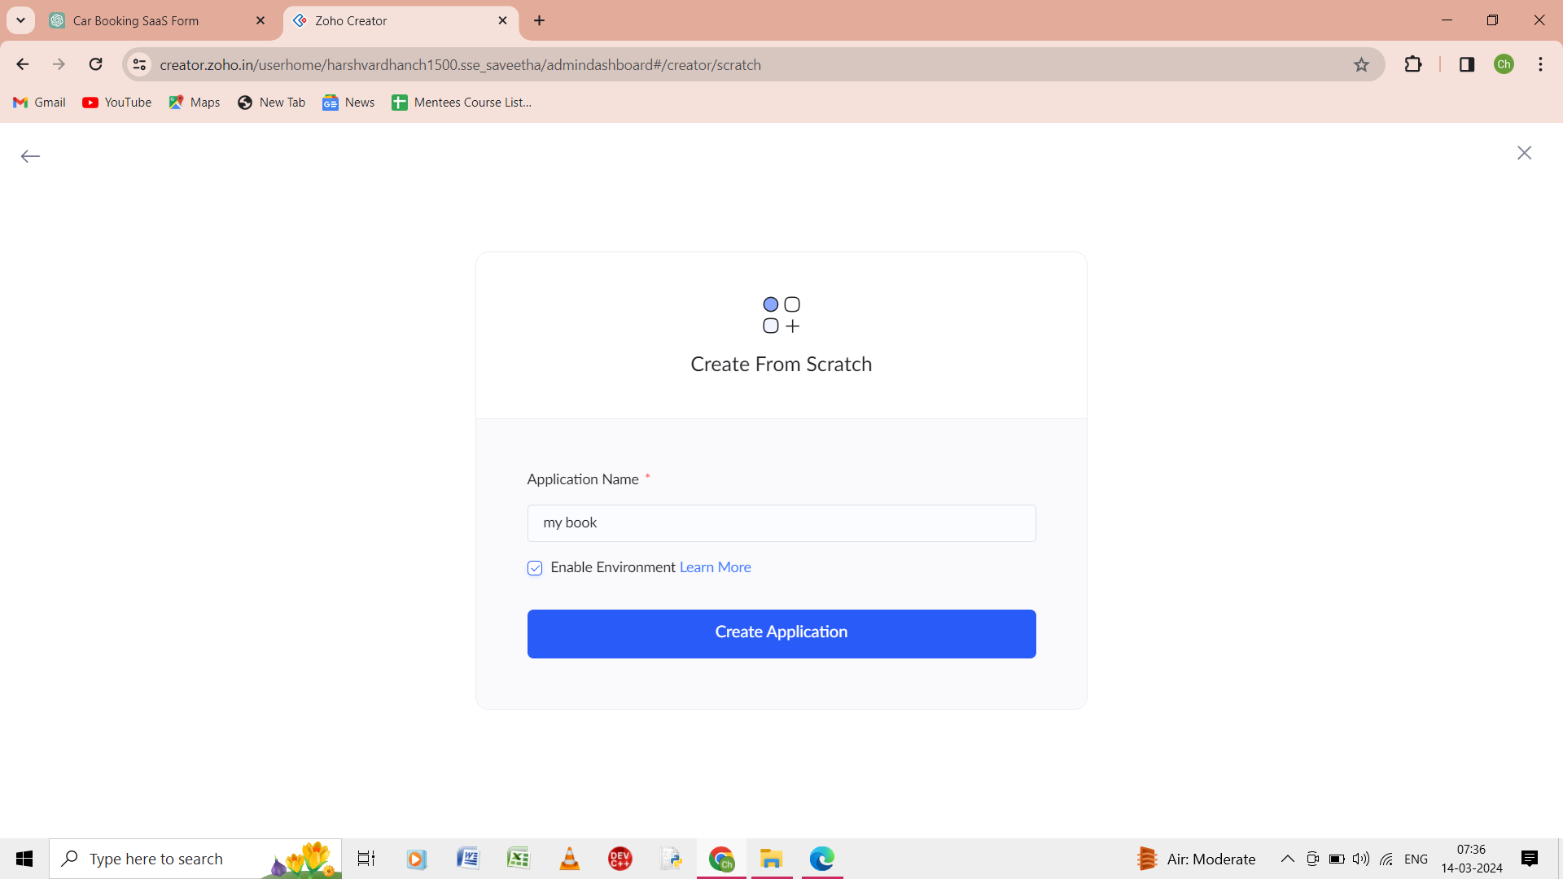

Step 1: from the scratch give the application as the my book.

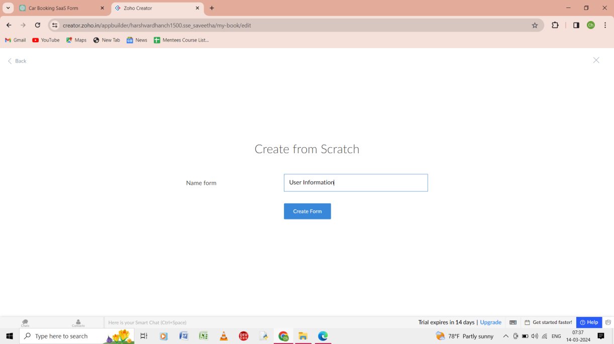

Step 2: from the scratch give the form as th user information.

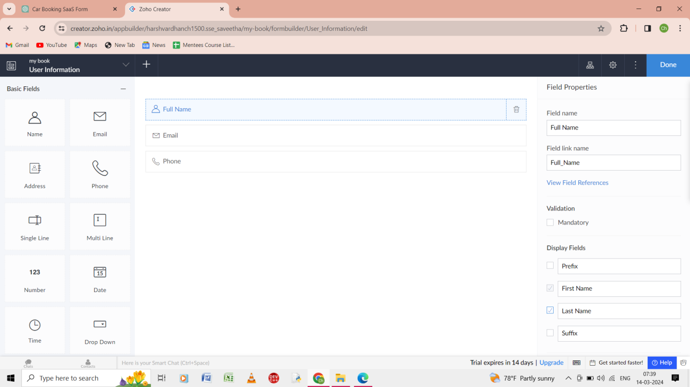

Step 3: give the user information as the name, email, phone in the input.

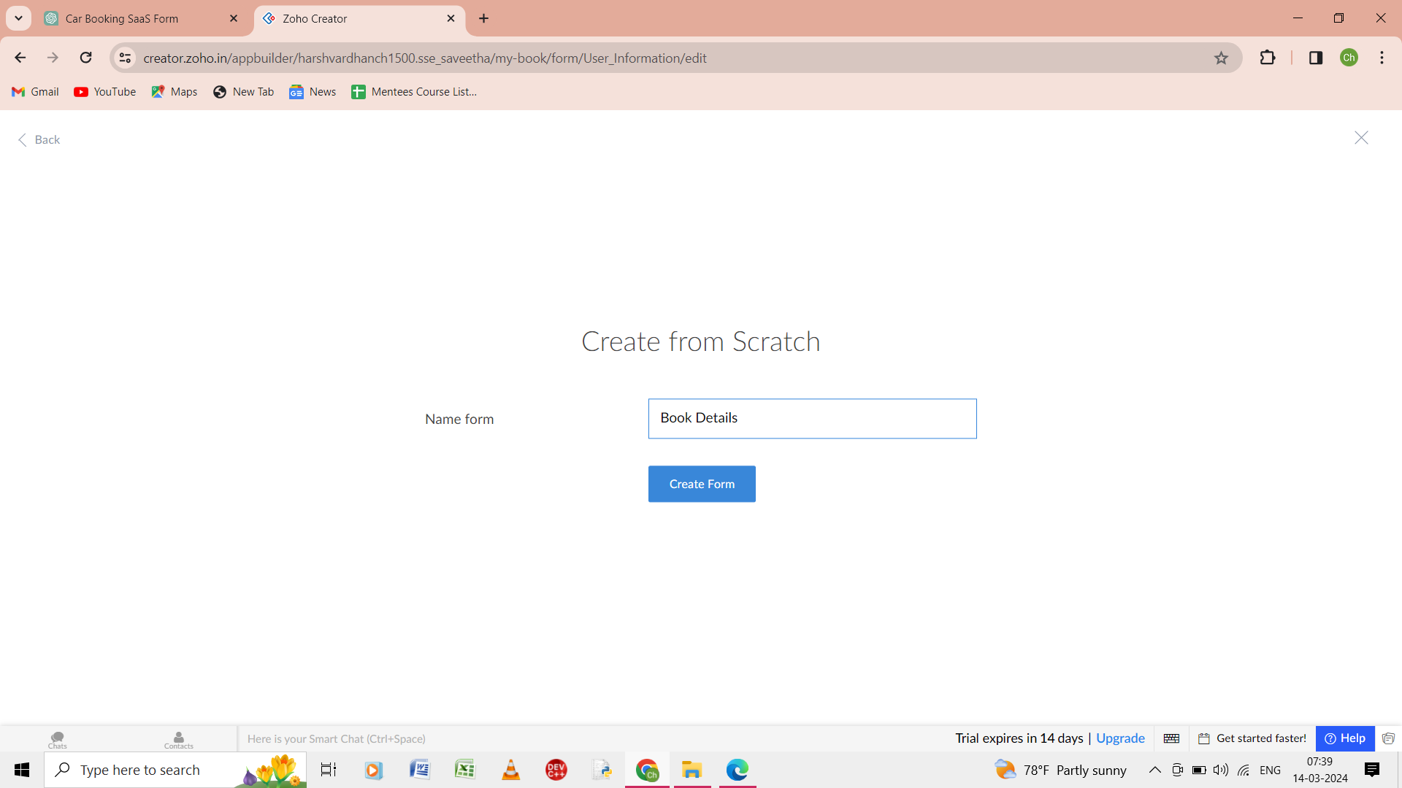

Step 4: from the scratch give the form as the book details.

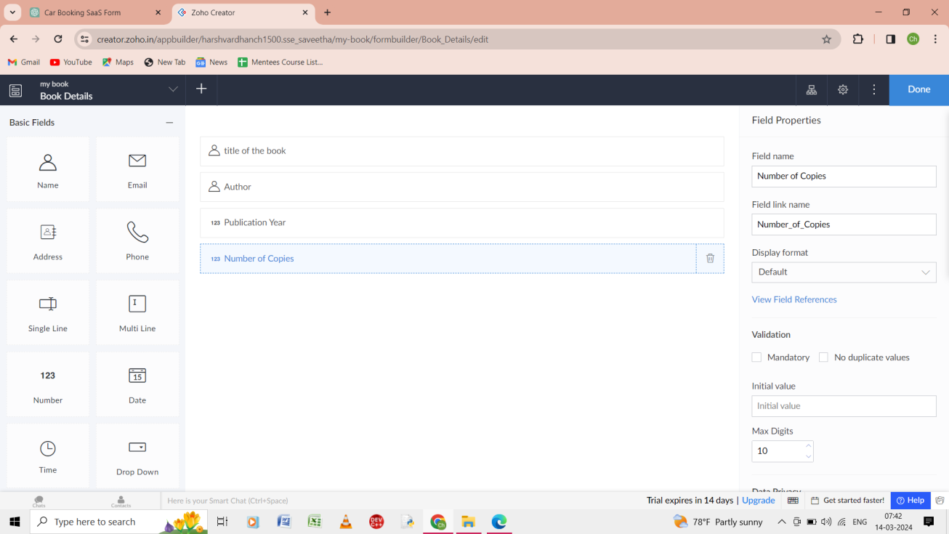

Step 5: In the form give the title of the book, author, publication year, number of copies.

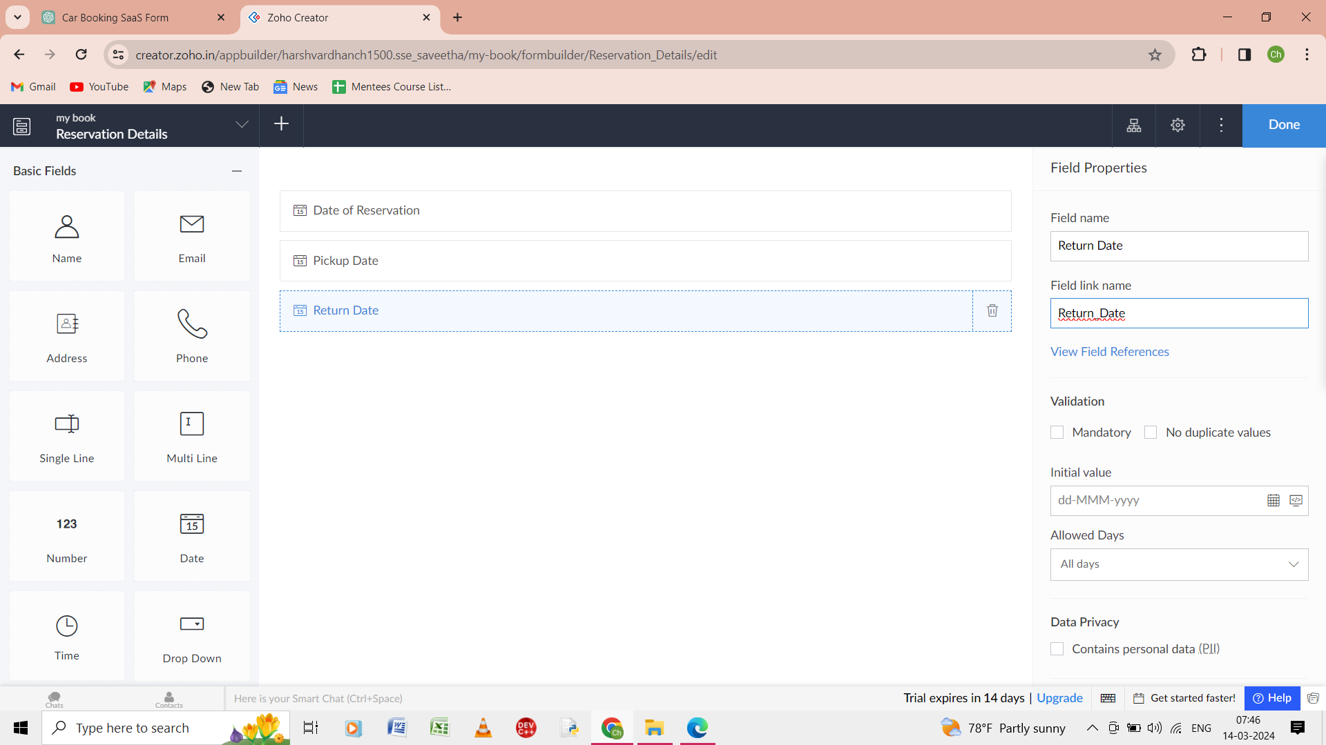

Step 6: give the input in the form as date of reservation, pickup date, return date.

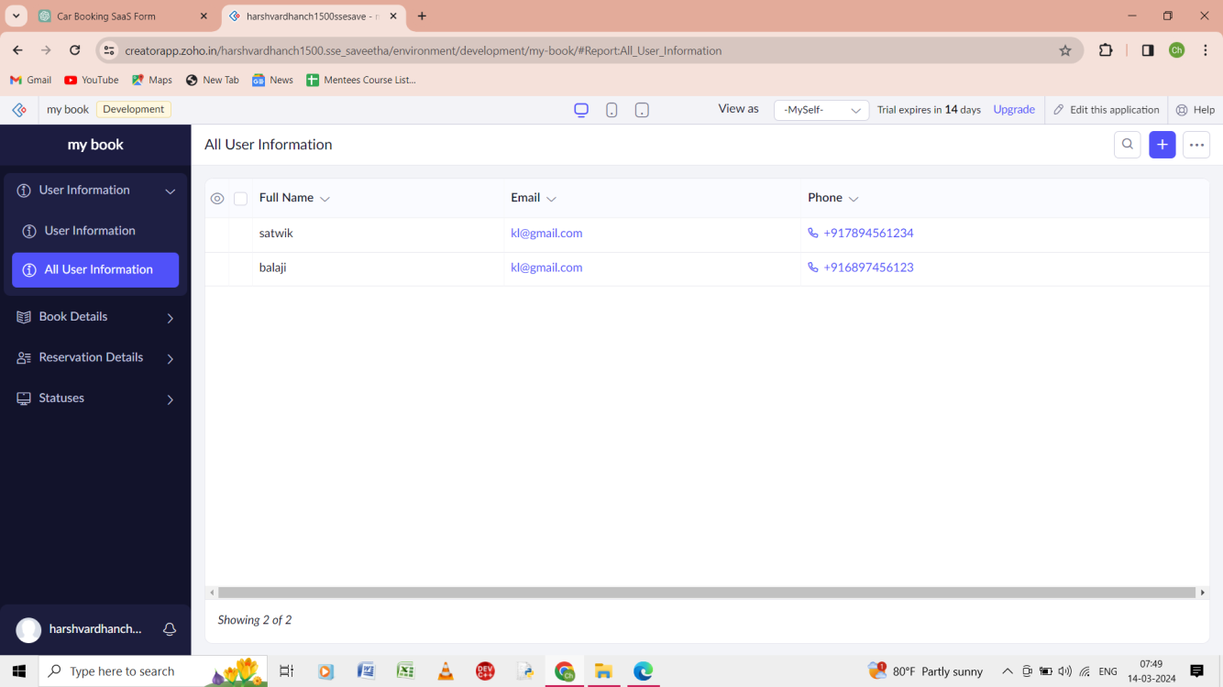

Step 7: the output of the user information of the form.

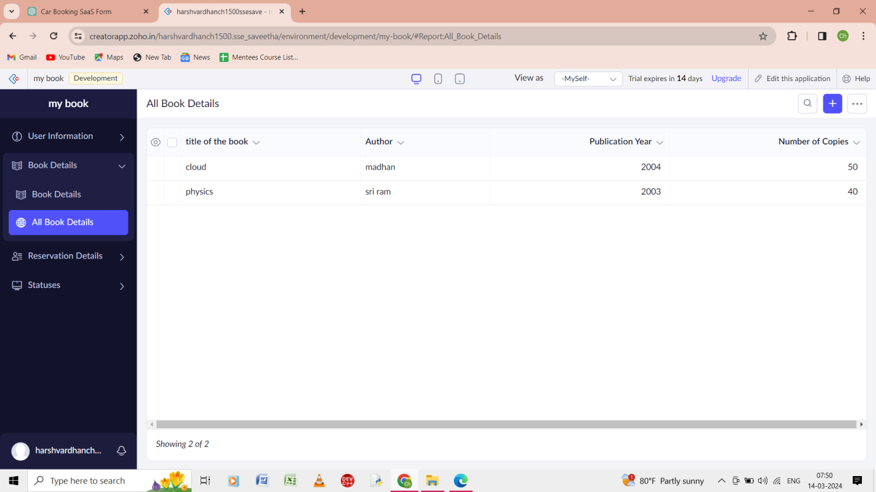

Step 8: the output of the all the book details of the form.

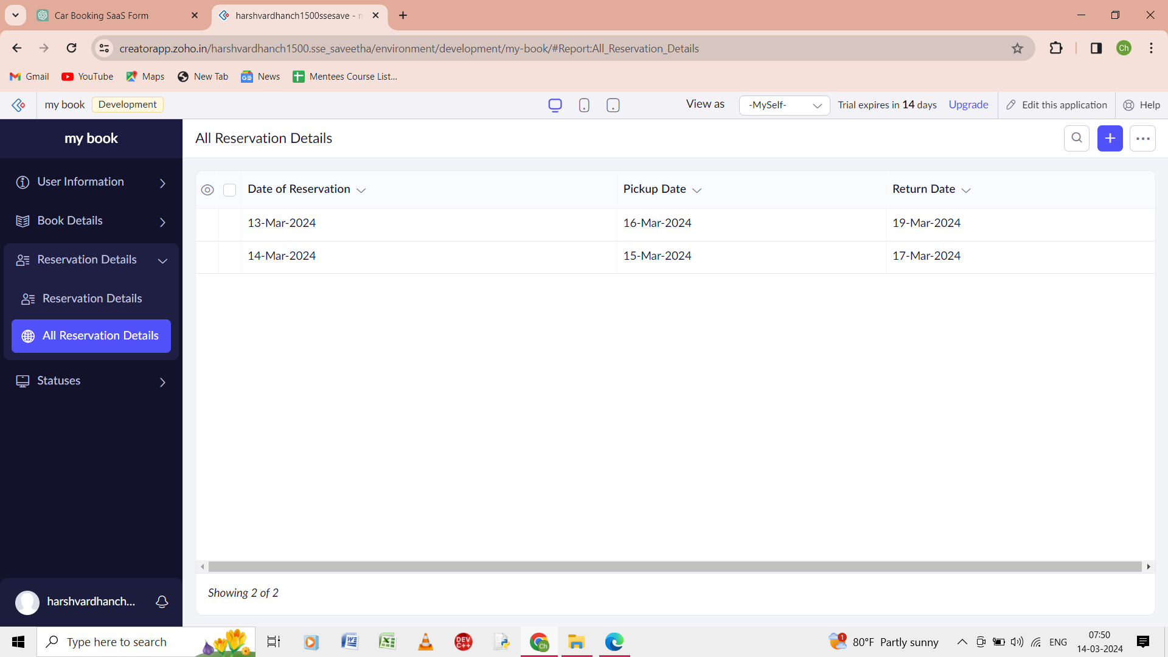

Step 9: the output of the reservation details of the form.

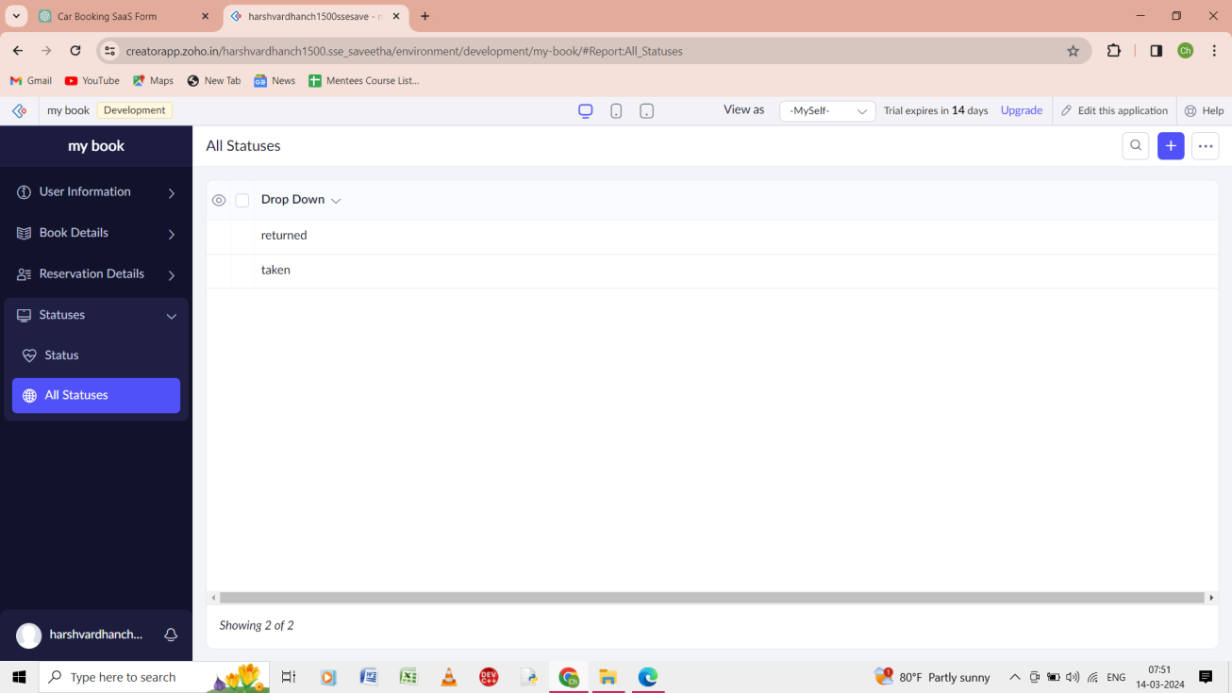

Step 10: the output the all the status of the form>